Name : S.Akilarasi
Reg no: 192512426
Ex.N.3: Spectrum Analysis of Sub-1 GHz, Mid-band & mmWave by Plotting Propagation Loss.
AIM: To analyze the propagation loss characteristics of different frequency bands (Sub-1 GHz, Midband, and mmWave) in wireless communication systems and compare their performance over varying distances using MATLAB.
Objective :
1. To compute the Propagation Loss (dB) for Sub-1 GHz, Mid-band, and mmWave frequency ranges using standard path loss models.
2. To evaluate the impact of different Operating Frequencies (GHz) on signal attenuation and coverage performance.
3. To analyze how Communication Distance (km) affects propagation loss across different spectrum bands.
Procedure:
clc; clear; close all;
d = 0.1:0.1:5;
f = [900 3500 28000]; % Distance (km) % Frequency (MHz)
PL1 = 32.44 + 20*log10(f(1)) + 20*log10(d);
PL2 = 32.44 + 20*log10(f(2)) + 20*log10(d);
PL3 = 32.44 + 20*log10(f(3)) + 20*log10(d);
figure
% -------- Graph 1 --------
subplot(2,1,1)
plot(d,PL1,'b','LineWidth',2);
hold on
plot(d,PL2,'r','LineWidth',2)
plot(d,PL3,'k','LineWidth',2)
title('192512216 Propagation Loss vs Distance')
xlabel('Distance (km)')
ylabel('Loss (dB)')
grid on
% -------- Graph 2 (NO legend used to avoid error) --------
subplot(2,1,2)
Freq = [900 3500 28000];
Loss = [PL1(10) PL2(10) PL3(10)];
plot(Freq,Loss,'-o','LineWidth',2)
title('192512216 Propagation Loss vs Frequency')
xlabel('Frequency (MHz)')
ylabel('Loss (dB)')
grid on
Output:
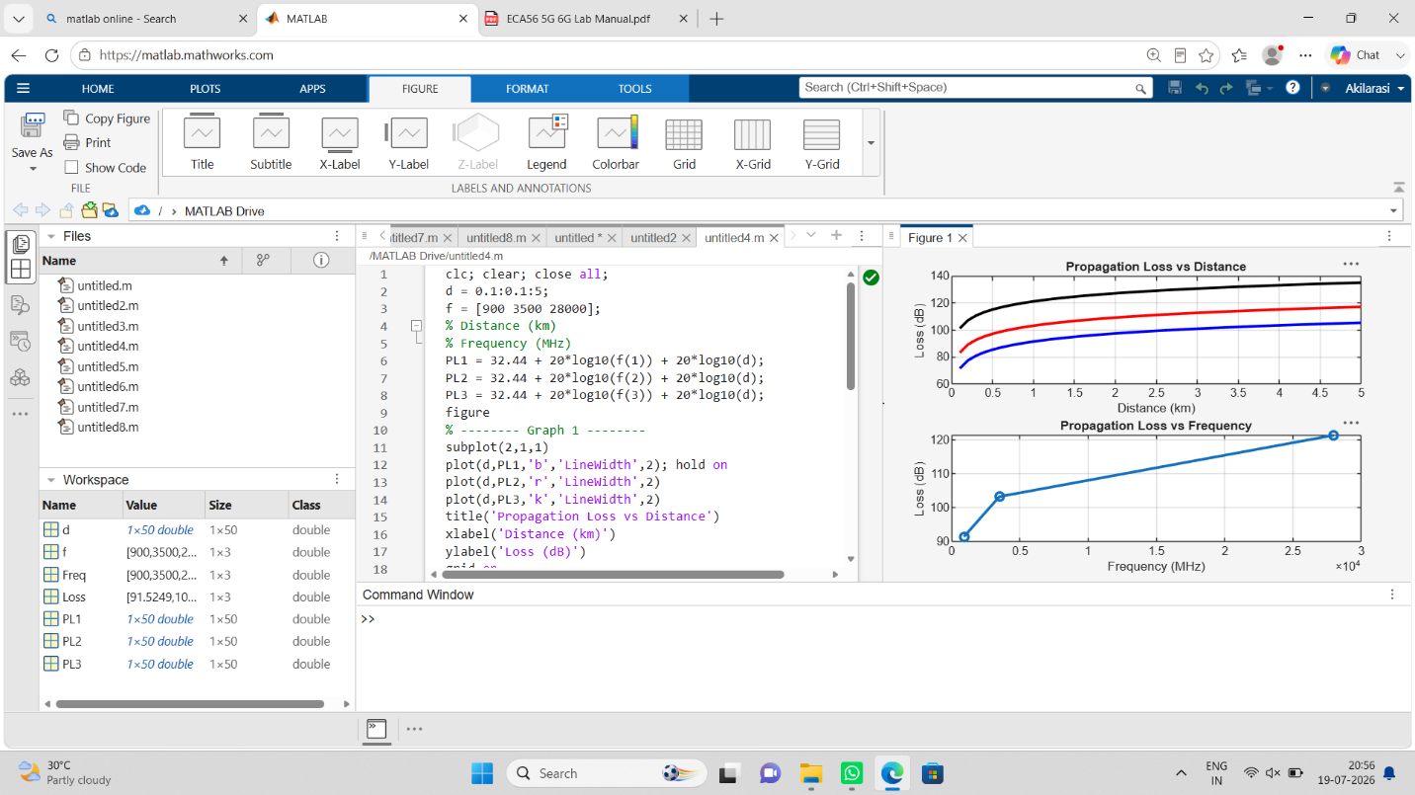

Objective 2:
clc; clear; close all;
d = 2; % fixed distance (km)
f = [900 3500 28000]; % MHz
PL = 32.44 + 20*log10(f) + 20*log10(d);
figure
% -------- Graph 1: Frequency vs Loss --------
subplot(2,1,1)
plot(f,PL,'-o','LineWidth',2)
title('192512216 Propagation Loss vs Operating Frequency')
xlabel('Frequency (MHz)')
ylabel('Propagation Loss (dB)')
grid on
% -------- Graph 2: Band Comparison --------
subplot(2,1,2)
bar(PL)
title('192512216 Comparison of Propagation Loss Across Bands')
xlabel('Frequency Bands (Index: 1=Sub-1GHz, 2=Mid-band, 3=mmWave)')
ylabel('Propagation Loss (dB)')
xticklabels({'Sub-1GHz','Mid-band','mmWave'})
grid on

Output:
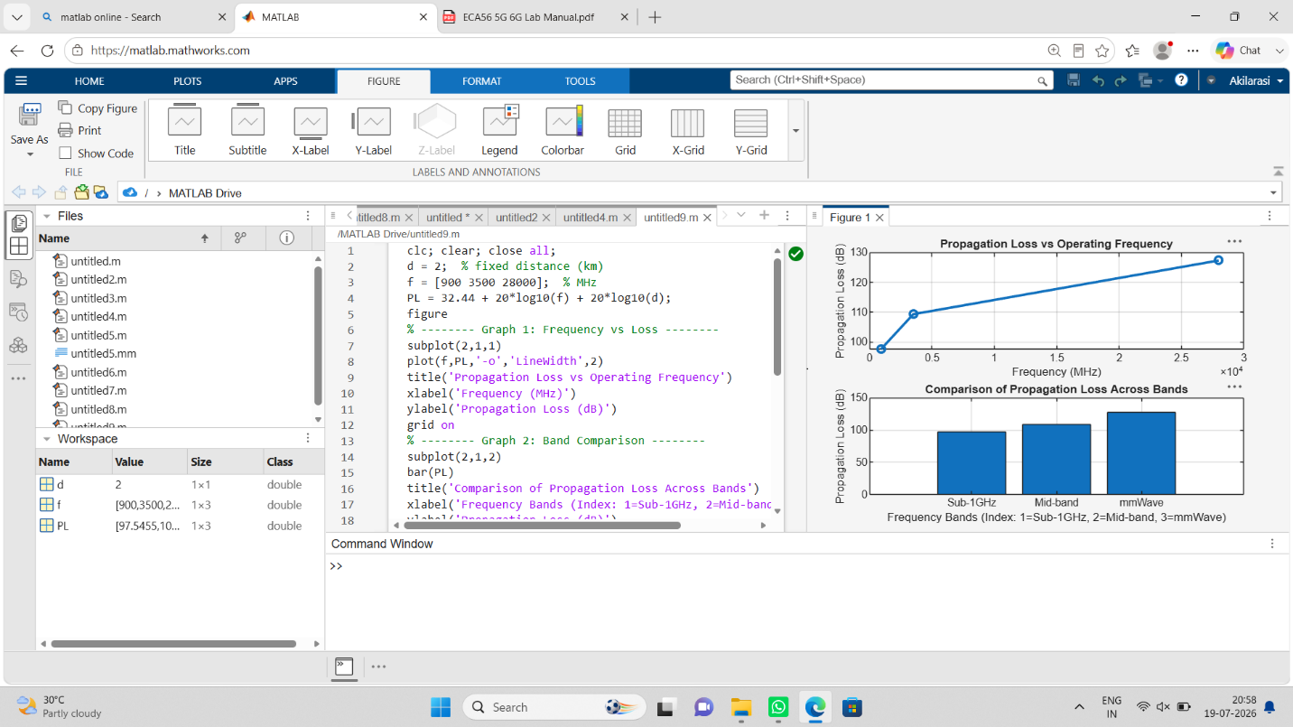

Objective 3:
clc; clear; close all;
% Frequency bands (MHz)
f = [900 3500 28000];
% Distance (km)
d = 2; % Propagation Loss (FSPL)
PL = 32.44 + 20*log10(f) + 20*log10(d);
figure
% -------- Graph 1: Simple Line Plot (SAFE) --------
subplot(2,1,1)
plot(f, PL, '-o', 'LineWidth', 2)
title('192512216 Propagation Loss vs Operating Frequency')
xlabel('Frequency (MHz)')
ylabel('Propagation Loss (dB)')
grid on
% -------- Graph 2: Safe Comparison Plot --------
subplot(2,1,2)
plot(1:3, PL, '-s', 'LineWidth', 2)
title('192512216 Band-wise Propagation Loss Comparison')
xlabel('Band Index (1=Sub1GHz, 2=Mid-band, 3=mmWave)')
ylabel('Propagation Loss (dB)')
grid on
Output:
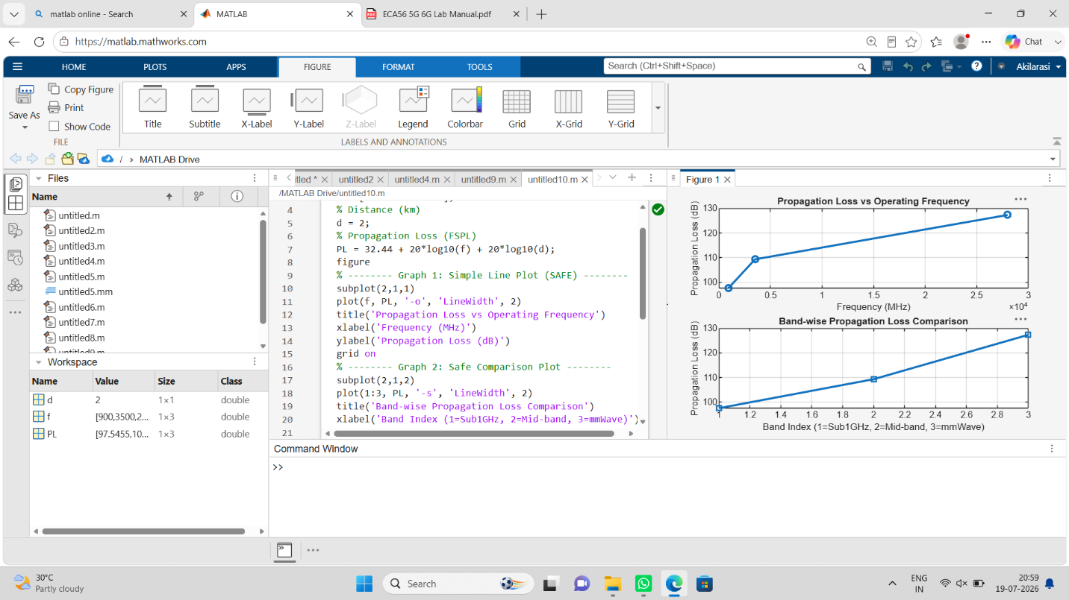

Result:
1. The propagation loss was successfully computed for Sub-1 GHz, Mid-band, and mmWave frequency bands using the Free Space Path Loss (FSPL) model.
2. It was observed that propagation loss increases with increase in operating frequency, with mmWave showing the highest attenuation and Sub-1 GHz showing the lowest loss.
3. The comparative analysis of spectrum bands clearly demonstrates that lower frequency bands are more suitable for long-range communication, while higher frequency bands require advanced techniques like beamforming for efficient performance.

